**Task 3- Order Data Analysis**

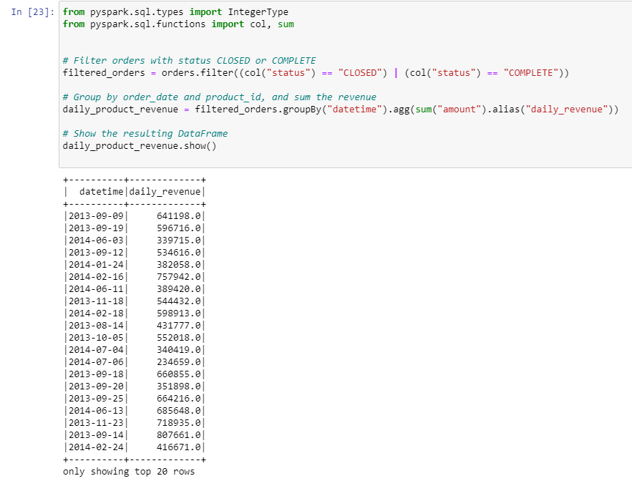

1. Orders

Products

Order Items

Departments

Customer

Categories

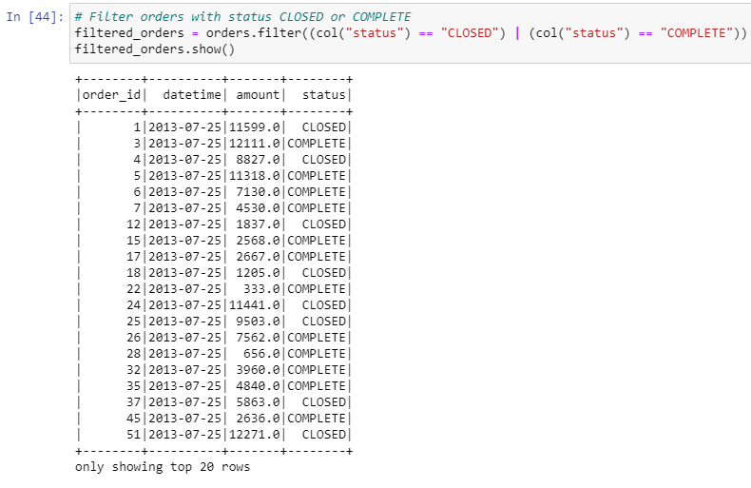

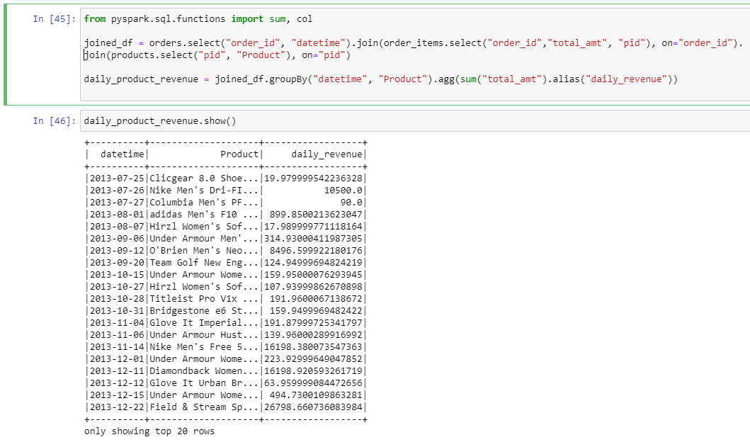

1. daily_product_revenue.write.partitionBy("Product").mode("overwrite").saveAsTable("db.daily_product_revenue")